
CSC455 - Computer Vision
Name: Aoun Haider
ID: FA21-BSE-133
Assignment: 02
Question 1: Bloom Taxonomy Level:<Applying>
from PIL import Image
import cv2
import numpy as np
import matplotlib.pyplot as plt
from google.colab.patches import cv2_imshow

def add_gaussian_noise(image, mean=0, std=25):
noise = np.random.normal(mean, std, image.shape).astype(np.uint8)
noisy_image = cv2.add(image, noise)
return noisy_image

def remove_noise(image, kernel_size=5):
return cv2.medianBlur(image, kernel_size)

def adaptive_thresholding(image, grid_size):
# Convert to HSV color space
hsv = cv2.cvtColor(cv2.cvtColor(image, cv2.COLOR_GRAY2BGR), cv2.COLOR_BGR2HSV)

# Create a mask for non-white pixels
lower = np.array([0, 0, 0])
upper = np.array([180, 255, 230])
mask = cv2.inRange(hsv, lower, upper)

# Apply morphological operations to clean up the mask
kernel = np.ones((5,5), np.uint8)
mask = cv2.morphologyEx(mask, cv2.MORPH_CLOSE, kernel, iterations=2)
mask = cv2.morphologyEx(mask, cv2.MORPH_OPEN, kernel, iterations=1)

# Fill holes
h, w = mask.shape[:2]
mask_floodfill = mask.copy()
cv2.floodFill(mask_floodfill, np.zeros((h+2, w+2), np.uint8), (0,0), 255)
mask_floodfill_inv = cv2.bitwise_not(mask_floodfill)
mask_filled = mask | mask_floodfill_inv

# Invert colors to make objects black
result = cv2.bitwise_not(mask_filled)

# Calculate histograms
histograms = []
cell_height, cell_width = image.shape[0] // grid_size[0], image.shape[1] // grid_size[1]
for i in range(grid_size[0]):
for j in range(grid_size[1]):
y1, y2 = i * cell_height, (i + 1) * cell_height
x1, x2 = j * cell_width, (j + 1) * cell_width
cell = image[y1:y2, x1:x2]
hist = cv2.calcHist([cell], [0], None, [256], [0, 256])
histograms.append(hist)

return result, histograms

def plot_histograms(histograms, grid_size):
fig, axes = plt.subplots(grid_size[0], grid_size[1], figsize=(20, 20))
axes = axes.ravel()

for i, hist in enumerate(histograms):
axes[i].plot(hist)
axes[i].set_title(f'Cell {i+1}')
axes[i].set_xlim([0, 256])
axes[i].set_ylim([0, hist.max()])

plt.tight_layout()
plt.show()

def display_images(images, titles):
fig, axes = plt.subplots(2, 2, figsize=(12, 12))
axes = axes.ravel()

for i, (image, title) in enumerate(zip(images, titles)):
axes[i].imshow(image, cmap='gray')
axes[i].set_title(title)
axes[i].axis('off')

plt.tight_layout()
plt.show()

def main(image_path, grid_size):
# Read the image in color
image = cv2.imread(image_path)

# Convert to grayscale for noise addition and removal
gray_image = cv2.cvtColor(image, cv2.COLOR_BGR2GRAY)

# Add Gaussian noise
noisy_image = add_gaussian_noise(gray_image)

# Remove noise using median filter
denoised_image = remove_noise(noisy_image)

# Apply adaptive thresholding with improved edge detection
thresholded, histograms = adaptive_thresholding(denoised_image, grid_size)

# Display results
display_images([gray_image, noisy_image, denoised_image, thresholded],
['Original Image', 'Noisy Image', 'Denoised Image (Median Filter)', 'Thresholded Image'])

if isinstance(thresholded, np.ndarray):
pil_image = Image.fromarray(thresholded)
else:
pil_image = thresholded

pil_image.save("image_downloaded.png", format="PNG")
# Plot histograms
plot_histograms(histograms, grid_size)

if __name__ == "__main__":
image_path = "/content/img_1.png" # Replace with your image path
grid_size = (5, 5) # Changed to 5x5 for better results with this method
main(image_path, grid_size)

Output:
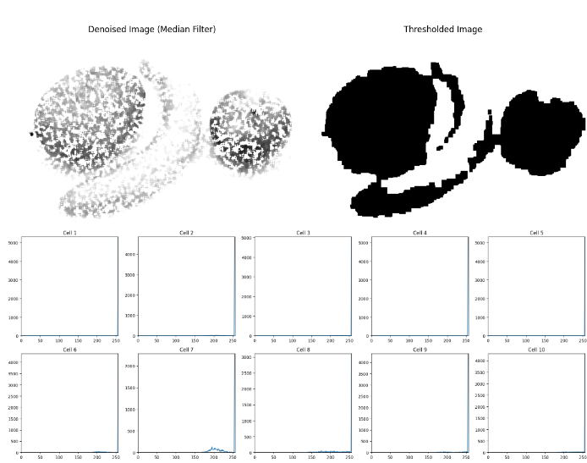
Question 2: (i)
import cv2
import numpy as np
import matplotlib.pyplot as plt
from google.colab.patches import cv2_imshow

def add_gaussian_noise(image, mean=0, std=25):
noise = np.random.normal(mean, std, image.shape).astype(np.uint8)
noisy_image = cv2.add(image, noise)
return noisy_image

def remove_noise(image, kernel_size=5):
return cv2.medianBlur(image, kernel_size)

def adaptive_thresholding(image, grid_size):
height, width = image.shape
cell_height, cell_width = height // grid_size[0], width // grid_size[1]

# Apply adaptive thresholding
thresholded = cv2.adaptiveThreshold(image, 255, cv2.ADAPTIVE_THRESH_GAUSSIAN_C, cv2.THRESH_BINARY_INV, 11, 2)

# Apply morphological operations to remove noise
kernel = np.ones((3,3), np.uint8)
thresholded = cv2.morphologyEx(thresholded, cv2.MORPH_CLOSE, kernel, iterations=2)
thresholded = cv2.morphologyEx(thresholded, cv2.MORPH_OPEN, kernel, iterations=1)

# Connected component analysis to remove small noise
num_labels, labels, stats, centroids = cv2.connectedComponentsWithStats(thresholded, connectivity=8)

# Remove small components (noise)
min_size = 100 # Adjust this value to control noise removal
for i in range(1, num_labels):
if stats[i, cv2.CC_STAT_AREA] < min_size:
thresholded[labels == i] = 0

# Invert the image to make objects black and background white
thresholded = cv2.bitwise_not(thresholded)

return thresholded, labels

def compute_area(labels, label):
return np.sum(labels == label)

def compute_centroid(labels, label):
y, x = np.where(labels == label)
return np.mean(x), np.mean(y)

def compute_perimeter(labels, label):
object_mask = (labels == label).astype(np.uint8)
contours, _ = cv2.findContours(object_mask, cv2.RETR_EXTERNAL, cv2.CHAIN_APPROX_NONE)
return len(contours[0])

def compute_circularity(area, perimeter):
return (4 * np.pi * area) / (perimeter ** 2)

def compute_region_properties(labels):
properties = []
for label in range(1, labels.max() + 1):
area = compute_area(labels, label)
centroid = compute_centroid(labels, label)
perimeter = compute_perimeter(labels, label)
circularity = compute_circularity(area, perimeter)

properties.append({
'label': label,
'area': area,
'centroid': centroid,
'perimeter': perimeter,
'circularity': circularity
})

return properties

def display_images(images, titles):
fig, axes = plt.subplots(2, 2, figsize=(12, 12))
axes = axes.ravel()

for i, (image, title) in enumerate(zip(images, titles)):
axes[i].imshow(image, cmap='gray')
axes[i].set_title(title)
axes[i].axis('off')

plt.tight_layout()
plt.show()

def main(image_path):
# Read the image
image = cv2.imread(image_path, cv2.IMREAD_GRAYSCALE)

# Add Gaussian noise
noisy_image = add_gaussian_noise(image)

# Remove noise using median filter
denoised_image = remove_noise(noisy_image)

# Apply adaptive thresholding
thresholded, labels = adaptive_thresholding(denoised_image, (10, 10))

# Compute region properties
properties = compute_region_properties(labels)

# Display results
display_images([image, noisy_image, denoised_image, thresholded],
['Original Image', 'Noisy Image', 'Denoised Image', 'Thresholded Image'])

# Print region properties
for prop in properties:
print(f"Object {prop['label']}:")
print(f" Area: {prop['area']}")
print(f" Centroid: {prop['centroid']}")
print(f" Perimeter: {prop['perimeter']}")
print(f" Circularity: {prop['circularity']:.4f}")
print()

if __name__ == "__main__":
image_path = "/content/image_downloaded.png" # Replace with your image path
main(image_path)
Output:
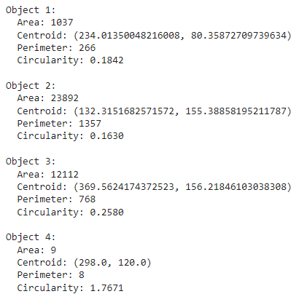
Question 2: (ii)
from PIL import Image, ImageDraw, ImageFont
import cv2
import numpy as np
import matplotlib.pyplot as plt

def label_fruits(image_path, output_path):
# Open the image
img = Image.open(image_path)
draw = ImageDraw.Draw(img)

# Load a font
try:
font = ImageFont.truetype("arial.ttf", 36)
except IOError:
font = ImageFont.load_default()

# Define fruits and their positions
fruits = [
("Mango", (50, 300)),
("Banana", (250, 300)),
("Apple", (450, 300))
]

# Add labels
for fruit, position in fruits:
draw.text(position, fruit, fill=(255, 255, 0), font=font)

# Save the labeled image
img.save(output_path)

def preprocess_image(image_path):
image = cv2.imread(image_path)
image = cv2.cvtColor(image, cv2.COLOR_BGR2RGB)
blurred_image = cv2.GaussianBlur(image, (5, 5), 0)
hsv_image = cv2.cvtColor(blurred_image, cv2.COLOR_RGB2HSV)
return image, hsv_image

def create_mask(hsv_image, lower, upper):
mask = cv2.inRange(hsv_image, lower, upper)
kernel = np.ones((5,5), np.uint8)
mask = cv2.morphologyEx(mask, cv2.MORPH_CLOSE, kernel)
mask = cv2.morphologyEx(mask, cv2.MORPH_OPEN, kernel)
return mask

def classify_fruits(original_image, hsv_image):
# Define color ranges for each fruit in HSV
banana_lower1 = np.array([20, 100, 100])
banana_upper1 = np.array([30, 255, 255])
banana_lower2 = np.array([30, 50, 200])
banana_upper2 = np.array([40, 100, 255])

mango_lower = np.array([20, 50, 50])
mango_upper = np.array([60, 255, 255])

apple_lower = np.array([0, 100, 100])
apple_upper = np.array([10, 255, 255])

# Create masks for each fruit
banana_mask1 = create_mask(hsv_image, banana_lower1, banana_upper1)
banana_mask2 = create_mask(hsv_image, banana_lower2, banana_upper2)
banana_mask = cv2.bitwise_or(banana_mask1, banana_mask2)
mango_mask = create_mask(hsv_image, mango_lower, mango_upper)
apple_mask = create_mask(hsv_image, apple_lower, apple_upper)

# Combine masks
combined_mask = banana_mask | mango_mask | apple_mask

# Find contours for the combined mask
contours, _ = cv2.findContours(combined_mask, cv2.RETR_EXTERNAL, cv2.CHAIN_APPROX_SIMPLE)

for contour in contours:
area = cv2.contourArea(contour)
if area > 5000: # Adjust this threshold as needed
x, y, w, h = cv2.boundingRect(contour)
roi = hsv_image[y:y+h, x:x+w]

# Calculate the percentage of pixels that match each fruit's color range
banana_percent = np.sum(create_mask(roi, banana_lower2, banana_upper2)) / (w * h)
mango_percent = np.sum(create_mask(roi, mango_lower, mango_upper)) / (w * h)
apple_percent = np.sum(create_mask(roi, apple_lower, apple_upper)) / (w * h)

# Classify based on the highest percentage
if banana_percent > mango_percent and banana_percent > apple_percent:
label = "Banana"
color = (255, 255, 0) # Yellow in RGB
elif mango_percent > apple_percent:
label = "Mango"
color = (0, 255, 0) # Green in RGB
else:
label = "Apple"
color = (255, 0, 0) # Red in RGB

cv2.rectangle(original_image, (x, y), (x + w, y + h), color, 2)
cv2.putText(original_image, label, (x, y - 10), cv2.FONT_HERSHEY_SIMPLEX, 0.9, color, 2)

return original_image

def main(image_path):
original_image, hsv_image = preprocess_image(image_path)
classified_image = classify_fruits(original_image, hsv_image)

plt.figure(figsize=(10, 10))
plt.imshow(classified_image)
plt.title("Fruits Classified and Labeled")
plt.axis("off")
plt.show()

# Example usage
image_path = "img_1.png" # Update this to your image path
main(image_path)

# Use the function
label_fruits("img_1.png", "part_b_2.png")
Output:
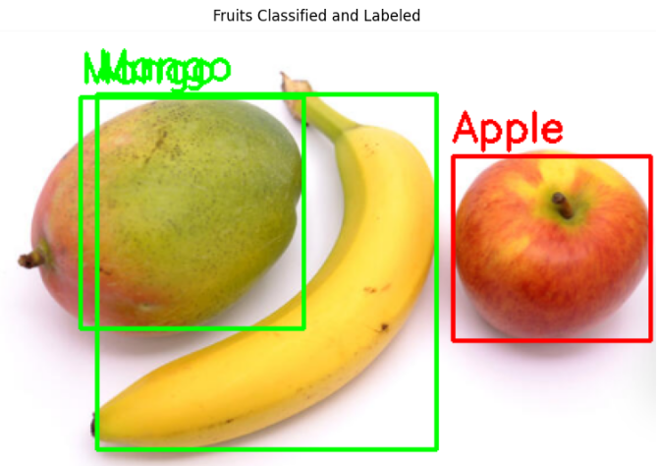
Question 2: (iii)
from PIL import Image, ImageDraw, ImageFont
import cv2
import numpy as np
import matplotlib.pyplot as plt
from rembg import remove
import io

def label_fruits(image_path, output_path):
# Open the image
img = Image.open(image_path)
draw = ImageDraw.Draw(img)

# Load a font
try:
font = ImageFont.truetype("arial.ttf", 36)
except IOError:
font = ImageFont.load_default()

# Define fruits and their positions
fruits = [
("Mango", (50, 300)),
("Banana", (250, 300)),
("Apple", (450, 300))
]

# Add labels
for fruit, position in fruits:
draw.text(position, fruit, fill=(255, 255, 0), font=font)

# Save the labeled image
img.save(output_path)

def preprocess_image(image_path):
image = cv2.imread(image_path)
image = cv2.cvtColor(image, cv2.COLOR_BGR2RGB)
return image

def remove_background(image_path):
with open(image_path, "rb") as input_file:
input_bytes = input_file.read()
output_bytes = remove(input_bytes)
output_image = Image.open(io.BytesIO(output_bytes))
output_array = np.array(output_image)

# Create a mask from the alpha channel
mask = output_array[:,:,3]

# Apply morphological operations to increase gaps between fruits
kernel = np.ones((7,7), np.uint8)
eroded_mask = cv2.erode(mask, kernel, iterations=2)
dilated_mask = cv2.dilate(eroded_mask, kernel, iterations=2)

# Apply the modified mask
rgb_image = cv2.cvtColor(output_array, cv2.COLOR_RGBA2RGB)
result = np.zeros_like(rgb_image)
for c in range(3):
result[:,:,c] = rgb_image[:,:,c] * (dilated_mask / 255)

# Set background to black
result[dilated_mask == 0] = [0, 0, 0]

return result

def classify_fruits(image):
hsv = cv2.cvtColor(image, cv2.COLOR_RGB2HSV)

# Define color ranges for oranges
orange_lower = np.array([10, 100, 100])
orange_upper = np.array([25, 255, 255])

# Define color ranges for mango (red and green components)
mango_red_lower = np.array([0, 50, 50])
mango_red_upper = np.array([10, 255, 255])
mango_green_lower = np.array([35, 50, 50])
mango_green_upper = np.array([85, 255, 255])

# Create masks
orange_mask = cv2.inRange(hsv, orange_lower, orange_upper)
mango_red_mask = cv2.inRange(hsv, mango_red_lower, mango_red_upper)
mango_green_mask = cv2.inRange(hsv, mango_green_lower, mango_green_upper)
mango_mask = cv2.bitwise_or(mango_red_mask, mango_green_mask)

# Find contours
contours_orange, _ = cv2.findContours(orange_mask, cv2.RETR_EXTERNAL, cv2.CHAIN_APPROX_SIMPLE)
contours_mango, _ = cv2.findContours(mango_mask, cv2.RETR_EXTERNAL, cv2.CHAIN_APPROX_SIMPLE)

labeled_image = image.copy()

# Label oranges
for contour in contours_orange:
area = cv2.contourArea(contour)
if area > 5000:
x, y, w, h = cv2.boundingRect(contour)
roi = hsv[y:y+h, x:x+w]
orange_ratio = np.sum((roi[:,:,0] >= 10) & (roi[:,:,0] <= 25)) / (w * h)
if orange_ratio > 0.5:
cv2.rectangle(labeled_image, (x, y), (x + w, y + h), (255, 165, 0), 2)
cv2.putText(labeled_image, "Orange", (x, y - 10), cv2.FONT_HERSHEY_SIMPLEX, 0.9, (255, 165, 0), 2)

# Label mango
for contour in contours_mango:
area = cv2.contourArea(contour)
if area > 10000:
x, y, w, h = cv2.boundingRect(contour)
roi = hsv[y:y+h, x:x+w]
red_ratio = np.sum((roi[:,:,0] >= 0) & (roi[:,:,0] <= 10)) / (w * h)
green_ratio = np.sum((roi[:,:,0] >= 35) & (roi[:,:,0] <= 85)) / (w * h)
if red_ratio > 0.1 and green_ratio > 0.1:
cv2.rectangle(labeled_image, (x, y), (x + w, y + h), (0, 255, 0), 2)
cv2.putText(labeled_image, "Mango", (x, y - 10), cv2.FONT_HERSHEY_SIMPLEX, 0.9, (0, 255, 0), 2)

return labeled_image

def main(image_path):
processed_image = remove_background(image_path)
classified_image = classify_fruits(processed_image)

original_image = cv2.imread(image_path)
original_image = cv2.cvtColor(original_image, cv2.COLOR_BGR2RGB)

plt.figure(figsize=(15, 5))
plt.subplot(131)
plt.imshow(original_image)
plt.title("Original Image")
plt.axis("off")

plt.subplot(132)
plt.imshow(processed_image)
plt.title("Processed Image (Background Removed)")
plt.axis("off")

plt.subplot(133)
plt.imshow(classified_image)
plt.title("Fruits Classified and Labeled")
plt.axis("off")

plt.tight_layout()
plt.show()

# Example usage
image_path = "img_2.png" # Update this to your image path
main(image_path)

# Use the function
label_fruits("img_2.png", "part_b_3.png")

Output:
